**HOME CALLING**

A Project Report

Submitted for the partial fulfillment for the award of the degree of

### MCA 2 SEMESTER

Submitted by

Saumya (ABMCA22126)

Komal Choudhary(ABMCA22093)

Shambhawi Kumari(ABMCA22161)

Rakshita Sharma(ABMCA22213)

Under the supervision of **Dr.Mainaz Faridi**

Name of the Mentor

**Dr.Mainaz Faridi**



**Department of Mathematics & Computing**

**Banasthali Vidyapith**

**Banasthali - 304022**

**Session: 2022-23**

**Certificate**

### Certified that Saumya,KomalChoudhary,Shambhawi Kumari, Rakshita Sharma has carried out the project work titled “HOME CALLING” from 29 December 2022 to 13 April,2023 for the award of the MCA 2 SEMESTER from Banasthali Vidyapith under my supervision. The thesis embodies result of original work and studies carried out by Student herself and the contents of the thesis do not form the basis for the award of any other degree to the candidate or to anybody else.

**Dr.Mainaz Faridi**

Assistant Professor

Banasthali Vidyapith

**Objective**

Home calling is to provide a safe and secure journey to the girls of Banasthali. With this, we will try to provide confusion and fraud-free journeys. Being a Banasthalite we all face some kind of issues at the time of going home many times we got scammed by the girls. who claimed that they are booking agents of buses and after getting the money they get vanished so our website will provide them with authorized information about transport systems like buses from Banasthali to their destination.

**TABLE OF CONTENTS**

**Content**

**1. Objective**

**2. Requirement Analysis (SRS)**

a. Requirement Specification

b. H/W Specification

c. S/W Specification

d. Product Functions

e. Use-case Diagrams

f. Assumptions and Dependencies

g. Interfaces

h. Software System Attributes

**3.System Design (SDS)**

a. High-level Design

b. ER Diagram

c. Database Design

d. Data flow Diagram

e. Flowchart

**4.Coding Code Images**

**5. Testing**

a. Test Cases

**SRS**

**1. Introduction**

**1.1 Purpose**

The document focuses on describing the software requirements of the project, and a website for generating homegoing journey plans for Banasthalites. This project would be carried out to meet the software development requirement of the home call. The document focuses on all the functional and non-functional performance and security requirements of the project

1.2 Scope

Our software product will be named home calling and it will be a website that will provide a home journey to bansathalites. it will give the information and booking links of the needed transport system like a bus. It will also provide connectivity between two people from the same destination.

2. Overall description

2.1 Product perspective

Home calling is to provide a safe and secure journey to the girls of Banasthali. With this, we will try to provide confusion and fraud-free journeys. Being a Banasthalite we all face some kind of issues at the time of going home, many times we got scammed by the girls who claimed that they are booking agents of buses and after getting the money they get vanished so our website will provide them with authorized information about transport systems like buses from Banasthali to their destination. It will also provide the connectivity means two or more girls from the same destination can connect.

**2.2General description**

**2.2.1 Hardware Interface**

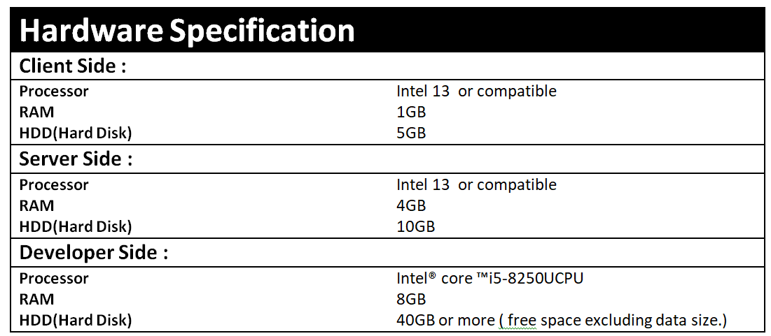

2.2.2 Software Interface

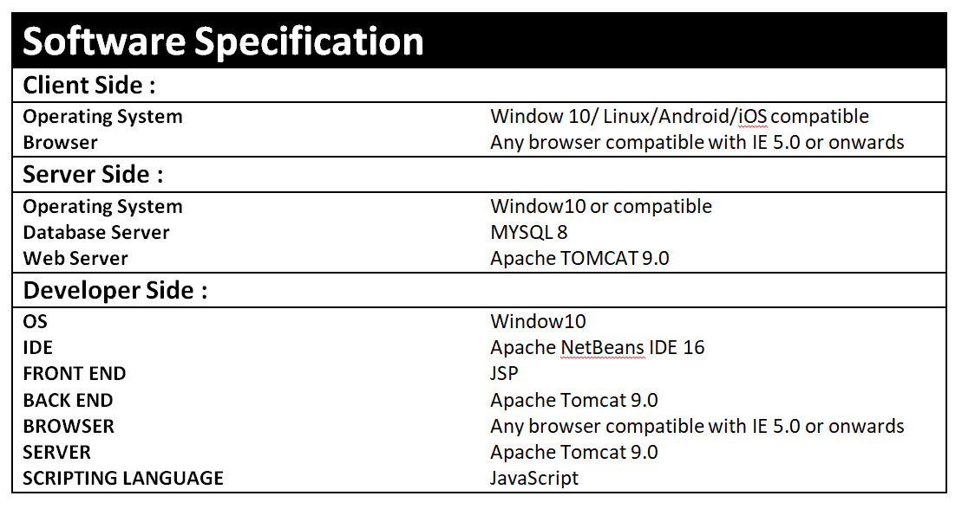

**2.2.3 Communication Interface**

1. Clients on Intranet will be using TCP/IP protocol.

2. Servers on the Internet will be using the HTTP/HTTPS protocol.

**2.3User Characteristics**

The user must be familiar with GUI components.

**1. Admin**: The head of the database. Only he can make changes like deleting users, managing buses, manage bus operators, and also can manage connectivity of two or more travel mates. He should be well-versed in using the system and should be known about the Database.

**2. Student**: In both the case of the individual and the group participant, we assume the students are computer literate, well aware of English, have a valid ID, and also type in the right kind of data.

**2.4 Assumptions and Dependencies**

1)Students can log in with their respective Smart Card ID and

password.

2) Internet facilities should available all the time.

3) Transaction would be applicable through credit/debit card or UPI.

**2.5 Technologies to be used**

Front End: HTML,CSS , Javascript

IDE:Netbeans

Technology : JSP/Servlet

**3. Specific Requirements**

**3.1 Functional Requirements**

The application shall have the following functional requirements:

➢ Booking  Module

➢ Create a destination

➢ Save destination

➢ Update destination info

➢ List destination

➢ Connect two people

**3.1.1 Register a profile**

➢ Users have the option to register a profile with  **Home Calling**from the menu bar.

➢ Select “Register” from the landing page, and follow the prompts to fill out and complete the registration.

a. Information will be stored on the database so the website can allow customers to plan/save/edit/delete trips in the future.

**3.1.2 Login to profile (edit, plan, view saved trips)**

From the homepage, users, once registered, can log in to their profile to

a) plan a destination

b) edit their profile details

c) view, edit, or cancel any saved destination.

**3.1.3 Logout to Profile**

Logout from the profile.

**3.1.4 Use Case Table**

**USE CASE TABLE FOR ADMIN**

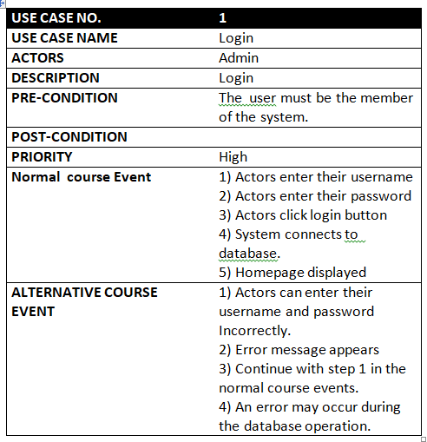

**USE CASE TABLE FOR  STUDENT**

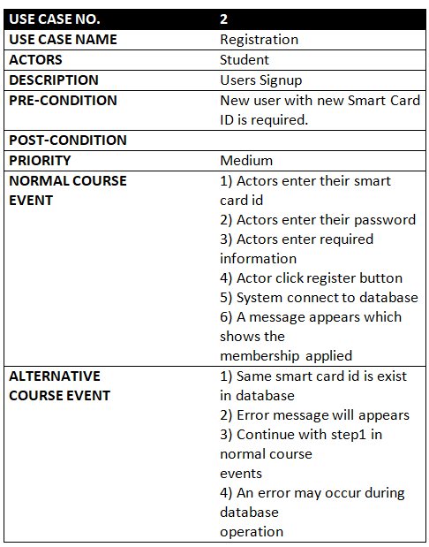

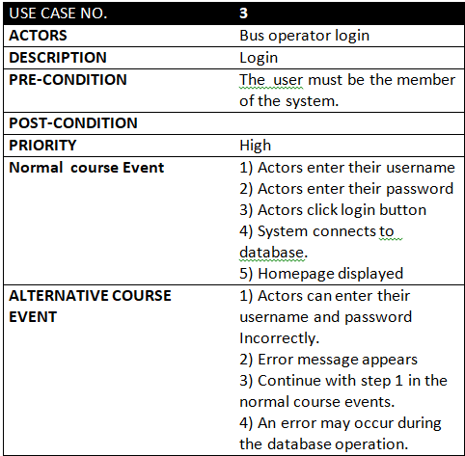

**3.1.5 Use Case Diagram**

ADMIN

**diagram Use Case Diagram For Admin  
Use**

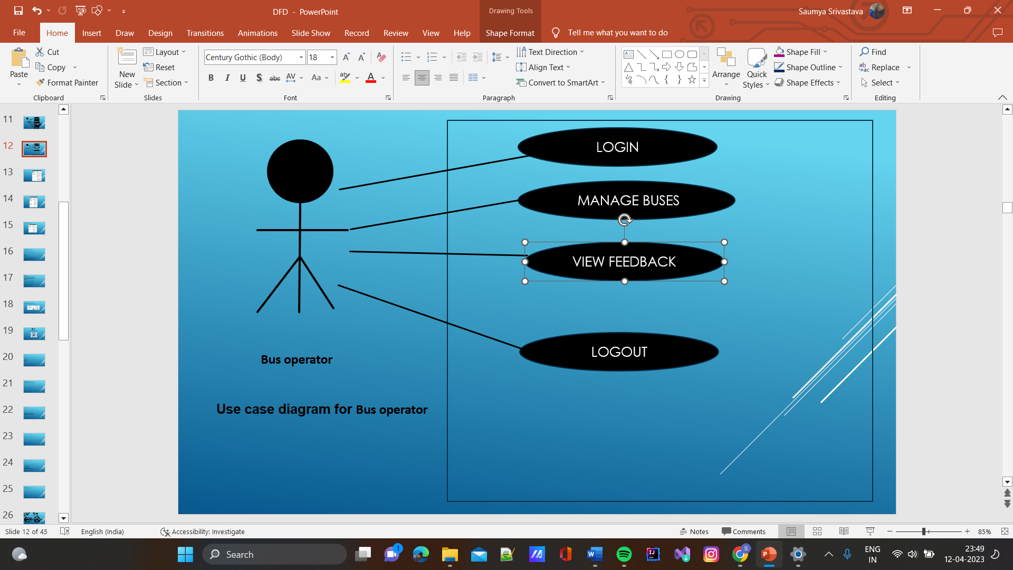

**Use Case Diagram For Student**

Student

**3.2  *Non functional Requirements(Software System Attributes)***

**Software System Attributes**

There are a number of quality attributes of software that can serve as requirements. It is important that required attributes be specified so that their achievement can be objectively verified.

**RELIABILITY**

All the information provided by the website Home Calling is reliable.

**AVAILABILITY**

The availability of the  website Home Calling depends upon the internet connection of the client. Since this is a client server-based website, the website will be available all the time. Students should have an account to access all the features of the website and in case, she is unregistered they should sign up to the system. Moreover, before signing up the guest students can browse through the website.

**SECURITY**

The authorization mechanism of the system will block unwanted attempts to the server and also let the system decide which privileges the students possess. The system has different types of students (Admin and Students), so there are different levels of authorization. The system has different modules which have been assigned certain functions, thus providing data abstraction and encapsulation.

**MAINTAINABILITY**

The requirements and modules that are explained in this document are enough to satisfy the student’s needs and requirements. The maintainability shall be easily done by integrating new modules and updating the existing modules at specific intervals of time.

**FLEXIBILITY**

Website can be used by different actors in their own manner. For the developers and designing team, the operational program can be modified and debugged so as to provide enhancements to the website.

**PORTABILITY**

The Home Calling  website is an online service created in a HTML framework and thus can easily be accessed by all.

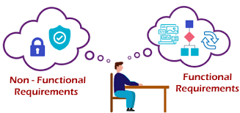

**SDS**

**SOFTWARE DESIGN SPECIFICATION**

**“HOME CALLING”**



**1. Introduction**

System Design Specification tells us how our software is going to build. It includes various diagrams to show the entire database and the relationship among all database tables.

The project “HOME CALLING” tries to give the experience of a confusion-free, fraud-free journey to home during holidays and casual leave. As the name suggests this project provides information on all routes, available seats in buses and connecting two people of the same destination. Our project is a one-stop solution for all journey-related problems. The software allows the sculpting of the database based on the requirement of the Banasthalite(who is willing to go home) and then provides all things according to their convenience and availability.

**1.1 Purpose**

1. To develop software for managing the journeys of Banasthalites. It is a powerful and user-friendly online service tool.

2. The software will computerize the existing journey style. The existing journey style has lots of confusion and fraud.

**1.2  Scope**

Our software product will be named HOME CALLING and it will be a website that will provide a home journey to Bansathalites it will give the information and booking links for the needed transport system.

**2 Component Interface Description**

**Admin**

I/P- Login and password

O/P- Logged in, admin can handle all the D/B updating. He can add new buses, announce the important dates, declare vacant seats, and view the feedback of the students regarding Buses.

**Registration**

I/P- Student name, smart card ID, password, course, email id, contact no.

O/P- Student gets registered.

**Vacant Sea**

I/P- Click on the particular Bus for which you want to get

information.

O/P- Information displayed.

**Booking**

I/P- Click on a particular results item (book seat).

O/P:-The desired  can book and see the detailed information

Regarding the bus.

**Connect to people**

I/P- Click the destination and connected with your travel mates.

O/P- Connected to the TravelMate.

**Dates and Announcements**

I/P- Click on a particular date.

O/P- Information regarding the scheduling of the different

Vehicles, people, and the like are displayed.

**3. High-Level Design**

High-level design (HLD) explains the architecture that would be used for developing a software product. The architecture diagram provides an overview of an entire system, identifying the main components that would be developed for the product and their interfaces. The HLD uses possibly nontechnical to mildly technical terms that should be understandable to the administrators of the system.

**ER Diagram**

An entity–relationship model (or ER model) describes interrelated things of interest in a specific domain of knowledge. A basic ER model is composed of entity types (which classify the things of interest) and specifies relationships that can exist between entities (instances of those entity types).

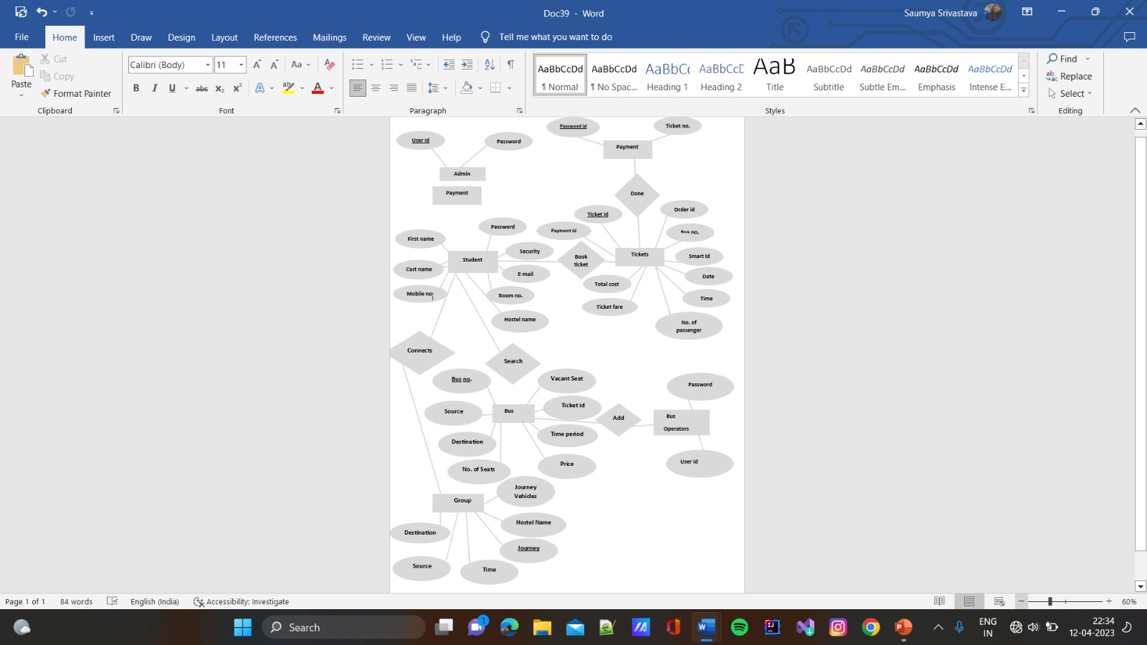

**Data Design**

Description:

i. In this we include, maintain & format the whole Database and its tables.

 ii. The tables corresponding to each of entity, holding the information about them are designed.

 iii. The tables have the fields, their description, and their data type as well as integrity constraint.

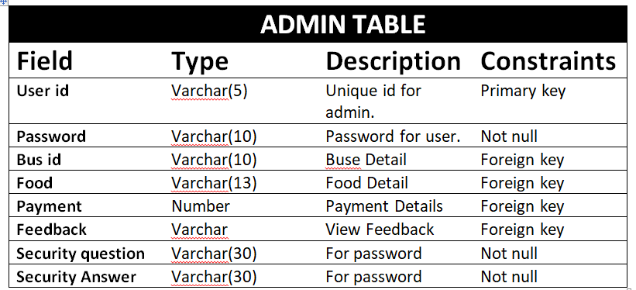

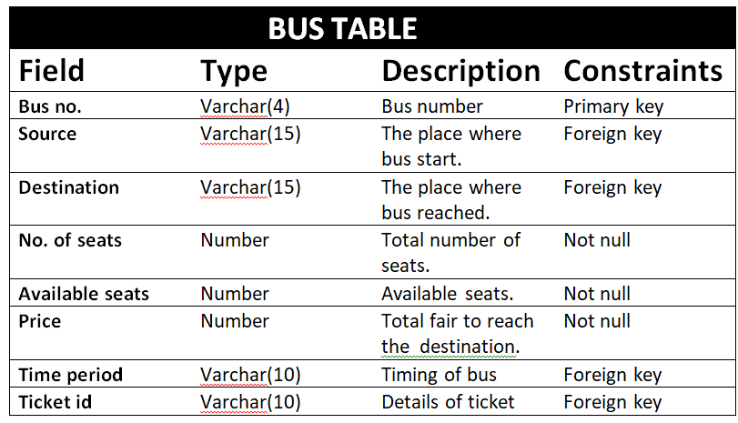

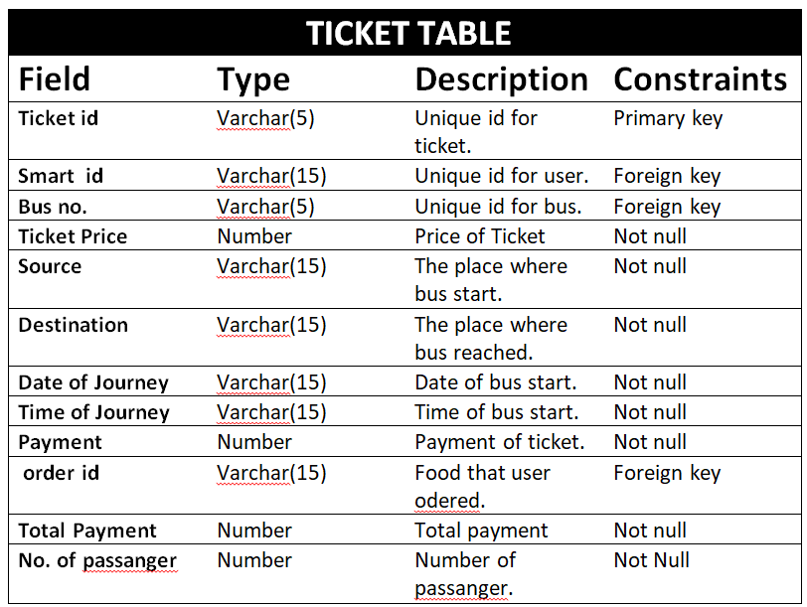

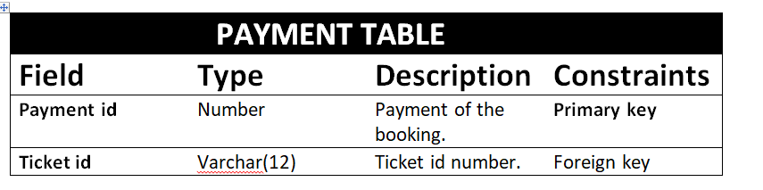

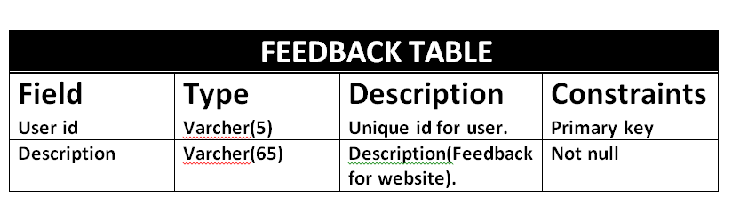

**Data Flow Diagram**

A data-flow diagram is a way of representing the flow of data of a process or a system (usually an information system). The DFD also provides information about the outputs and inputs of each entity and the process itself. A data-flow diagram has no control flow, there are no decision rules and no loops**.**

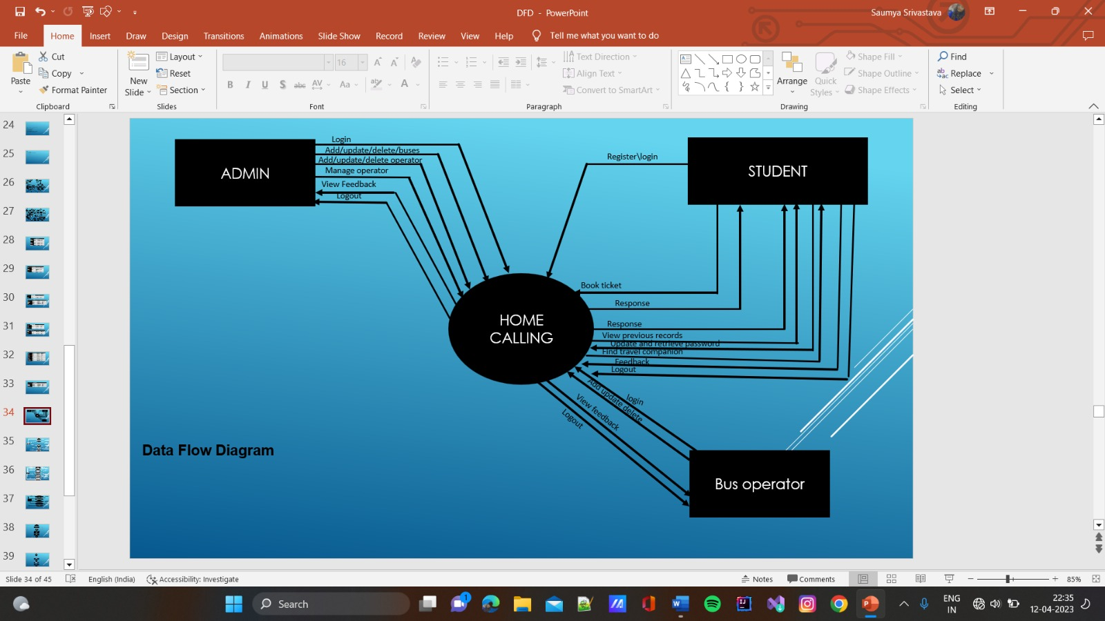

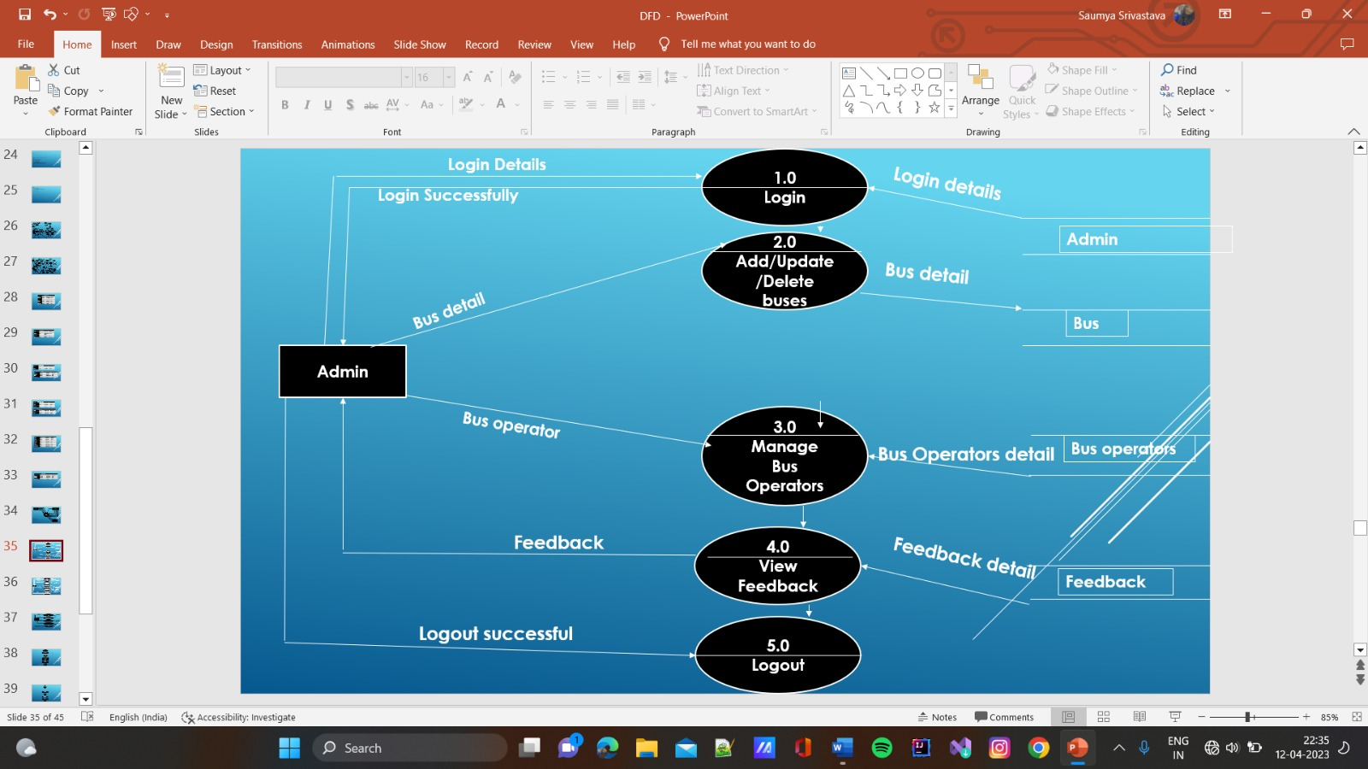

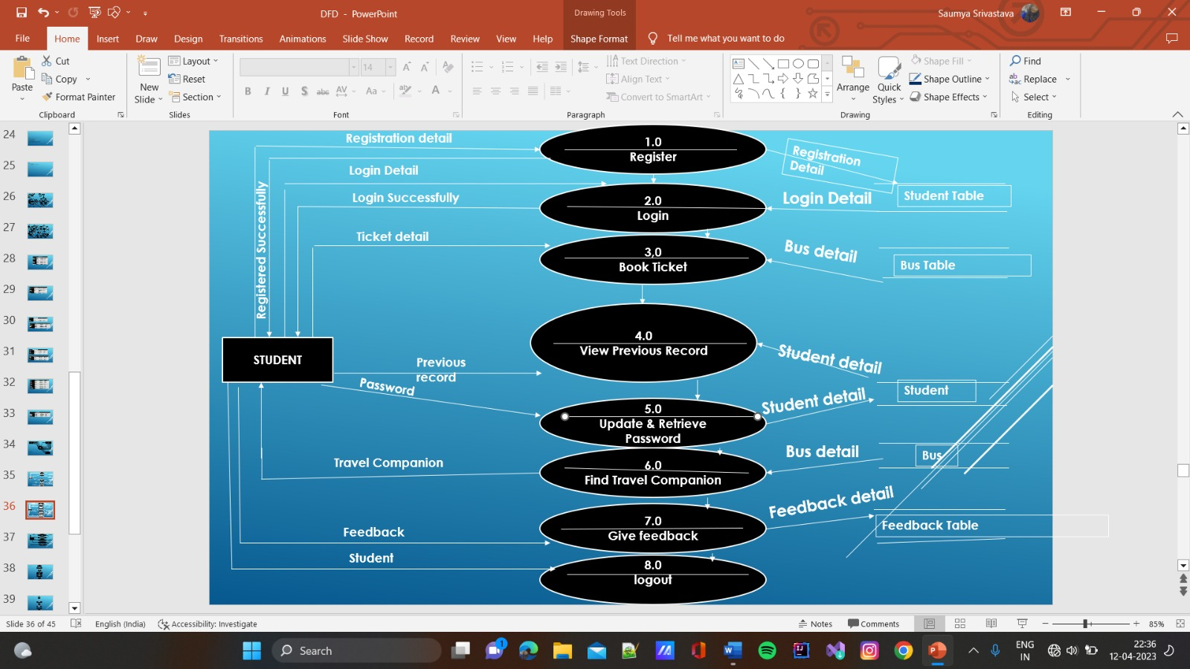

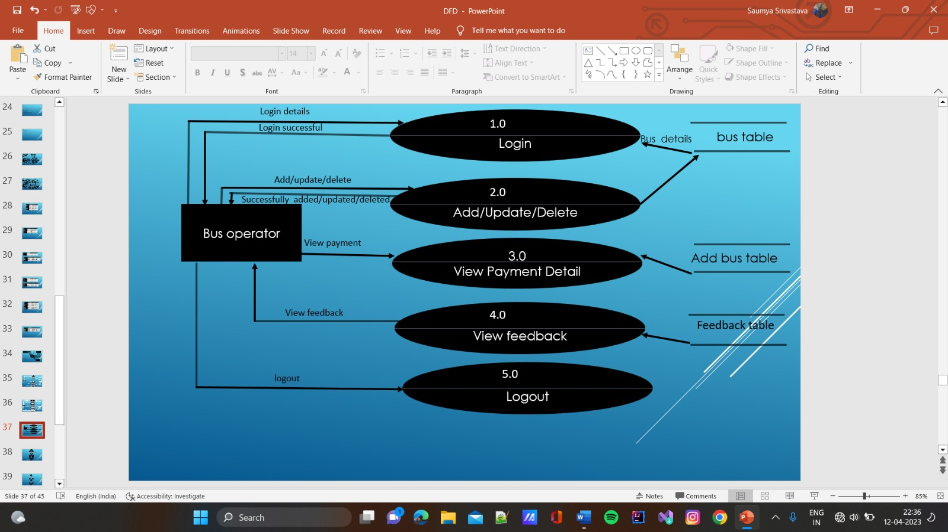

**Flow Charts**

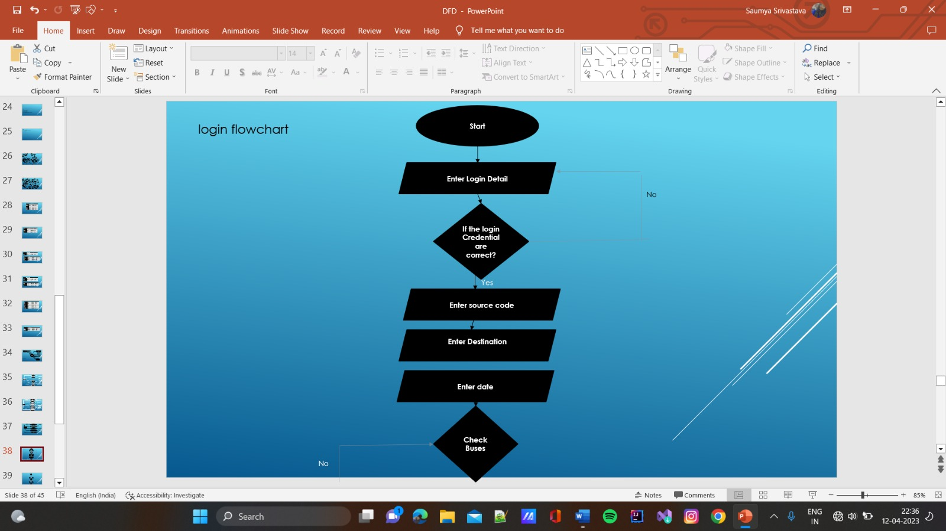

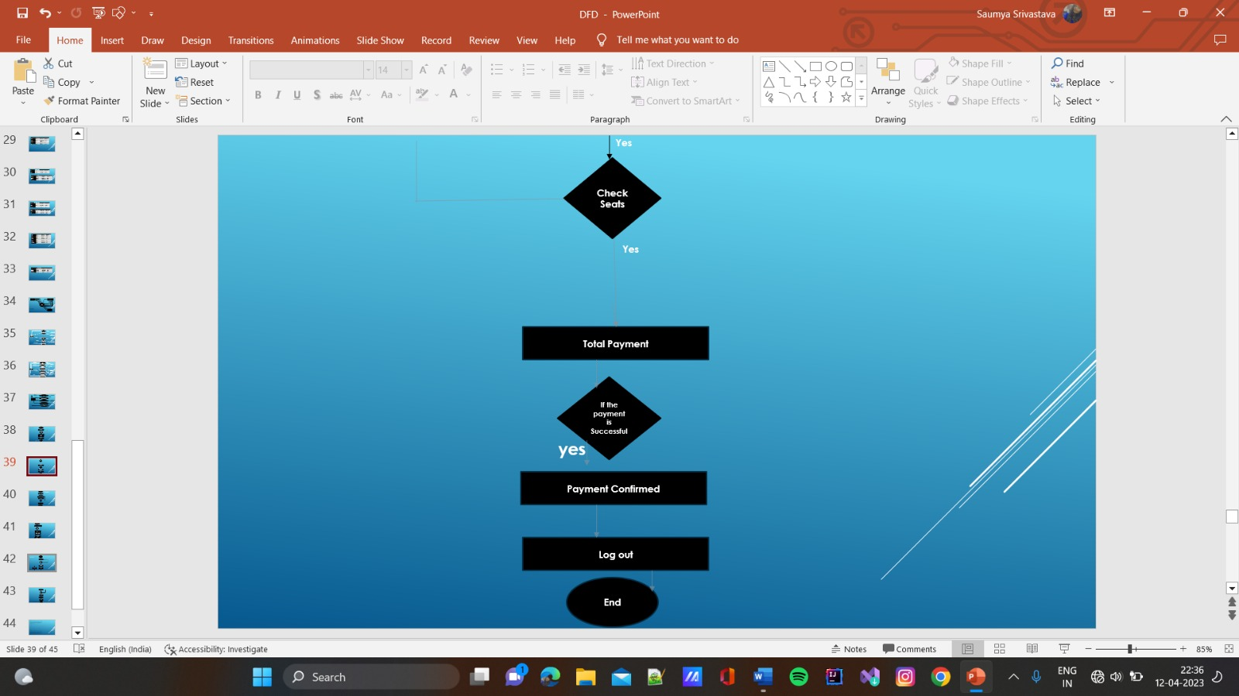

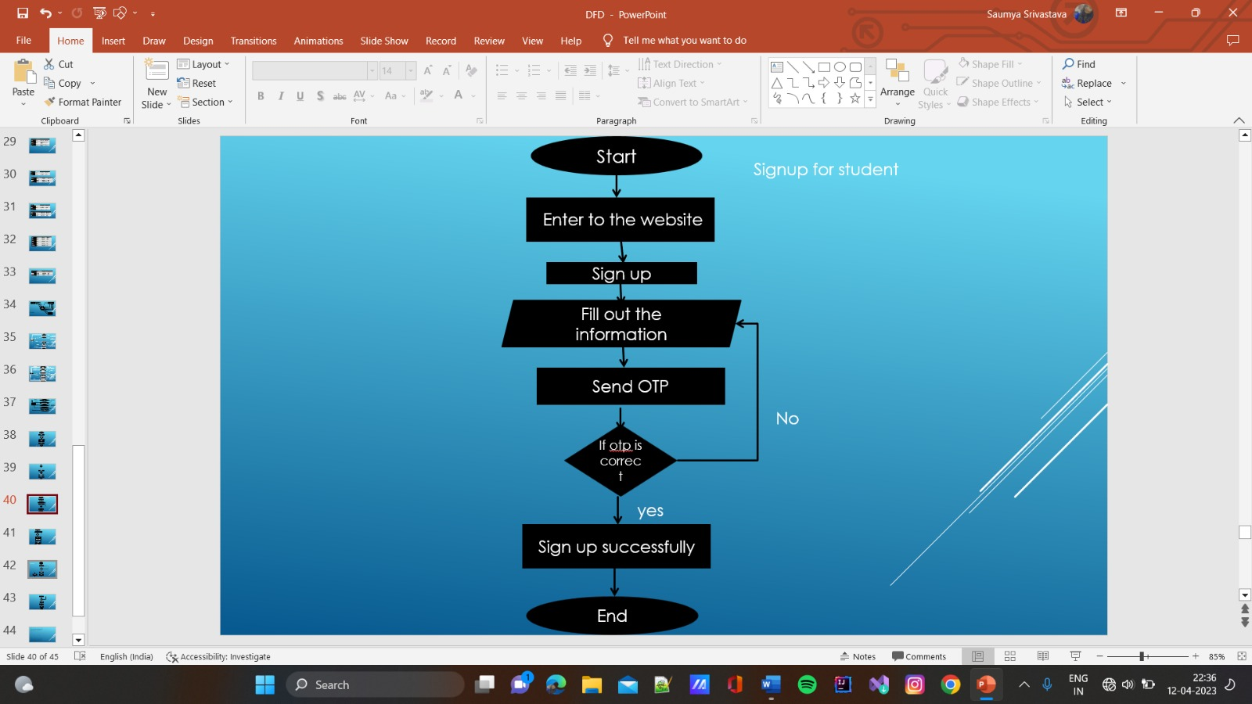

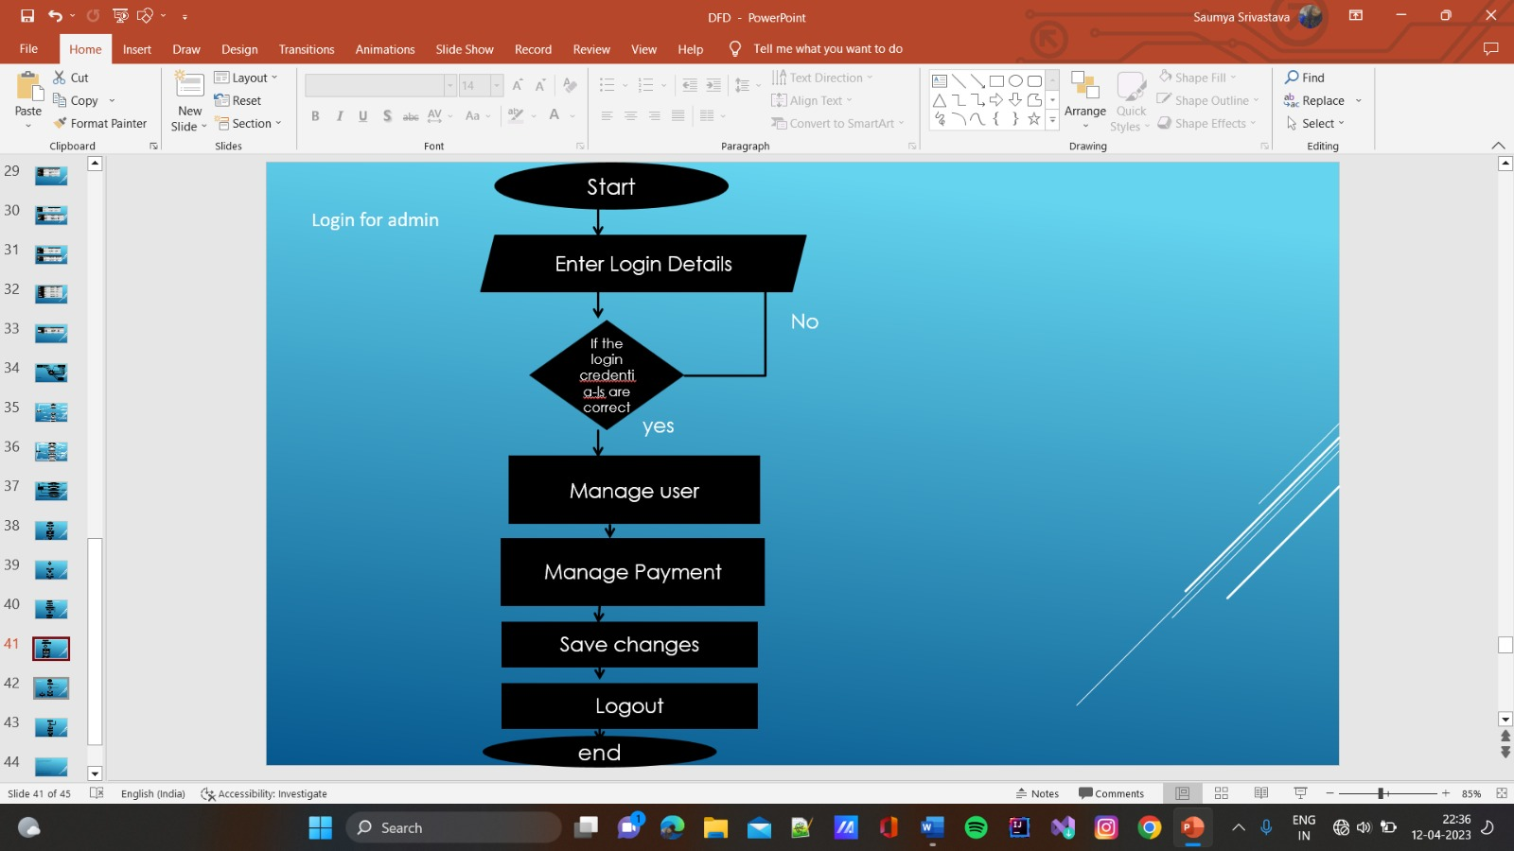

**Screenshots of coding**

**Index.jsp**

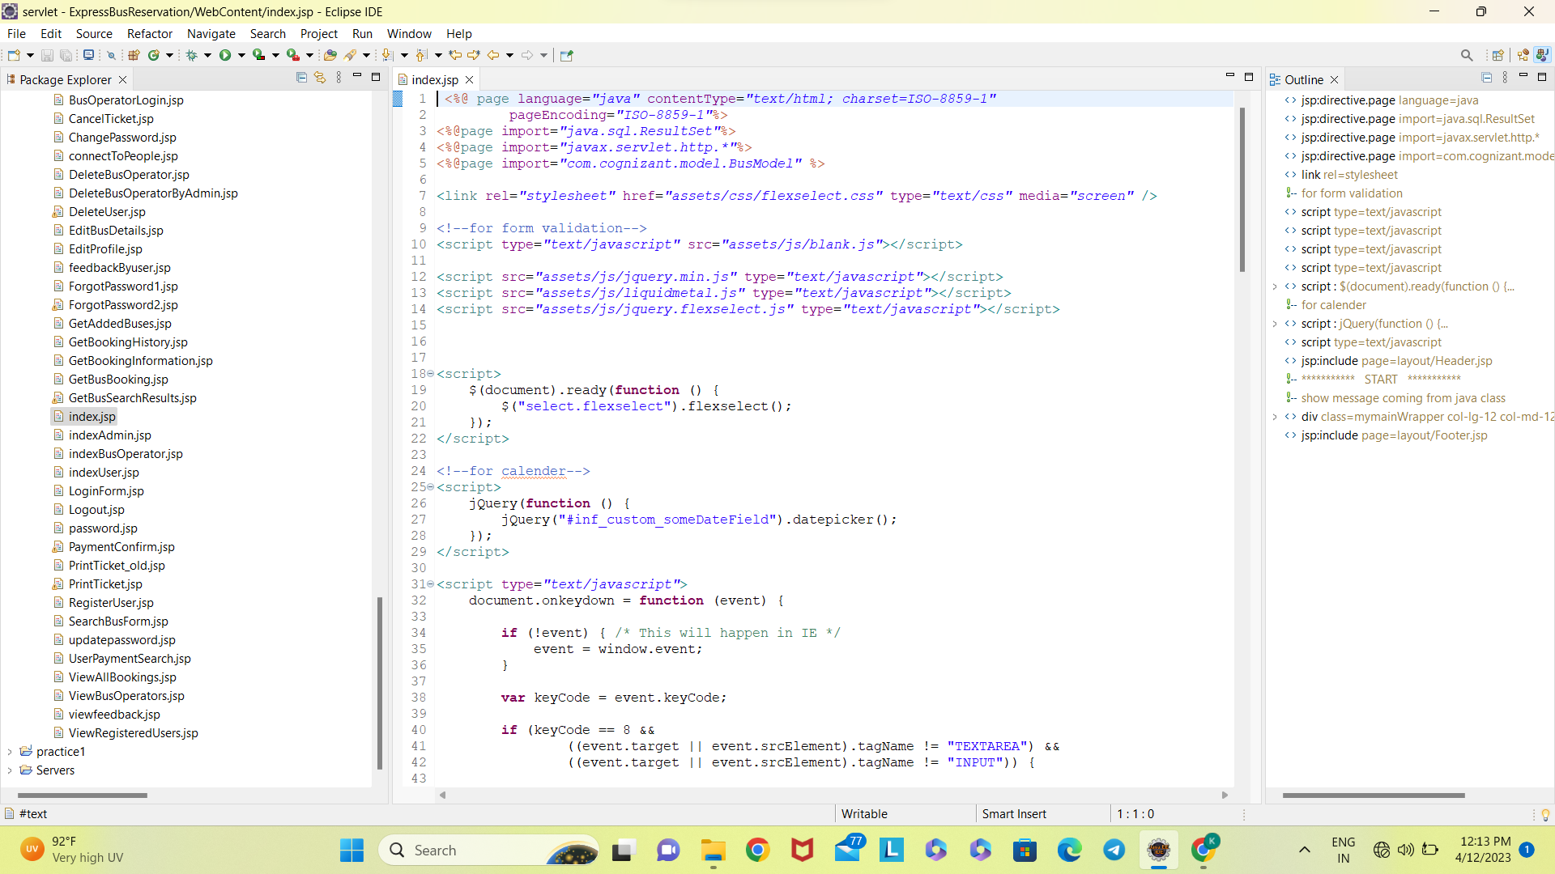

**IndexUser.jsp**

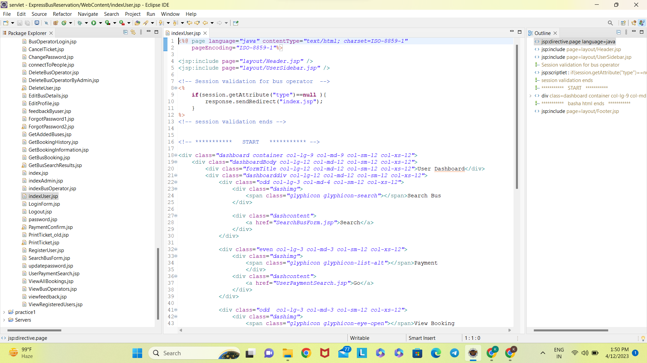

**IndexBusOperator.jsp**

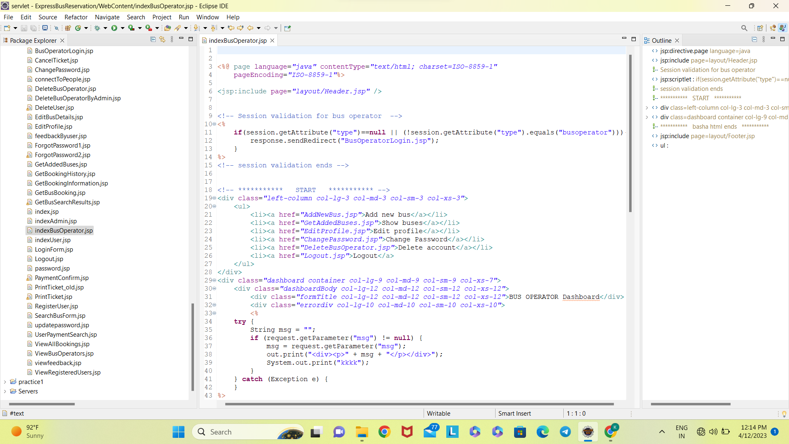

**Registration.jsp**

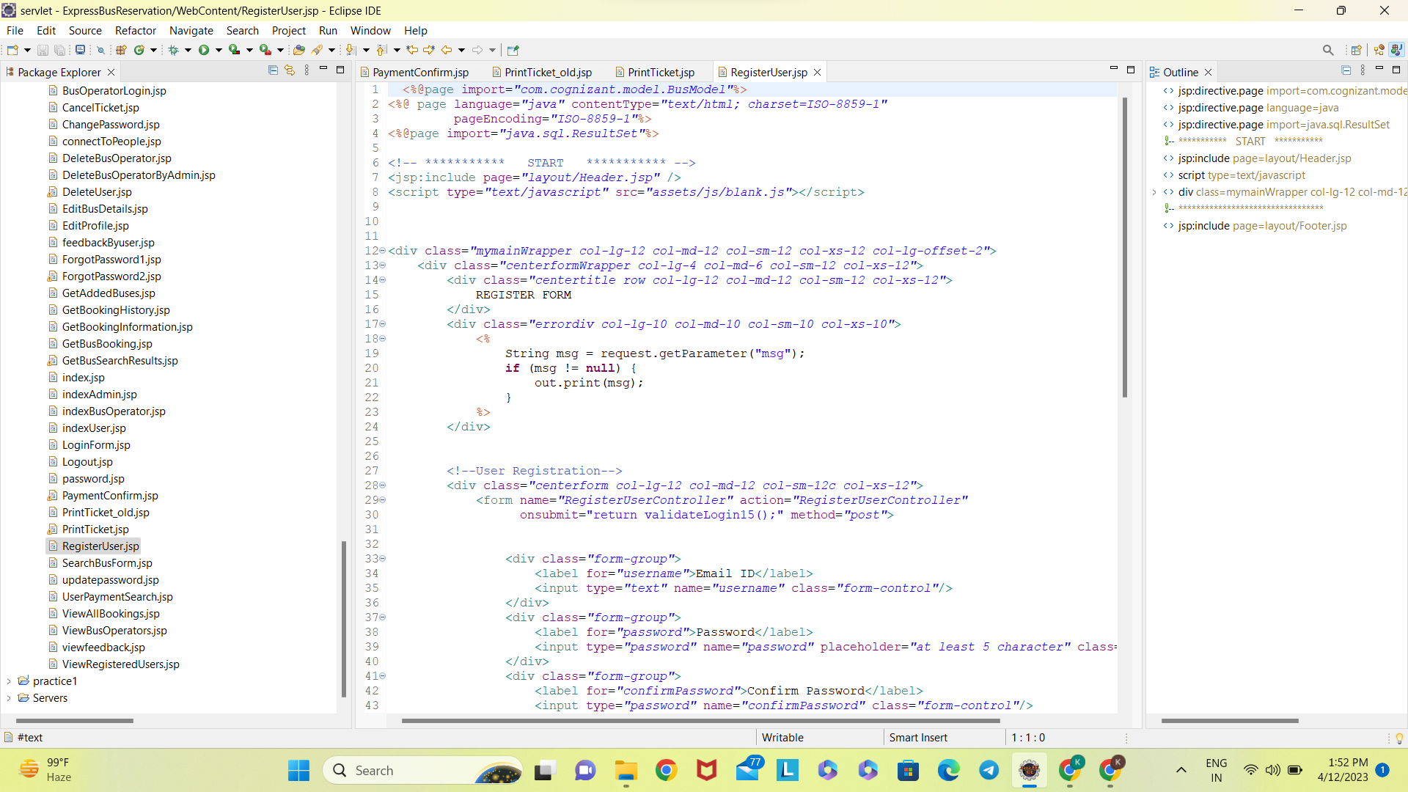

**loginUser.jsp**

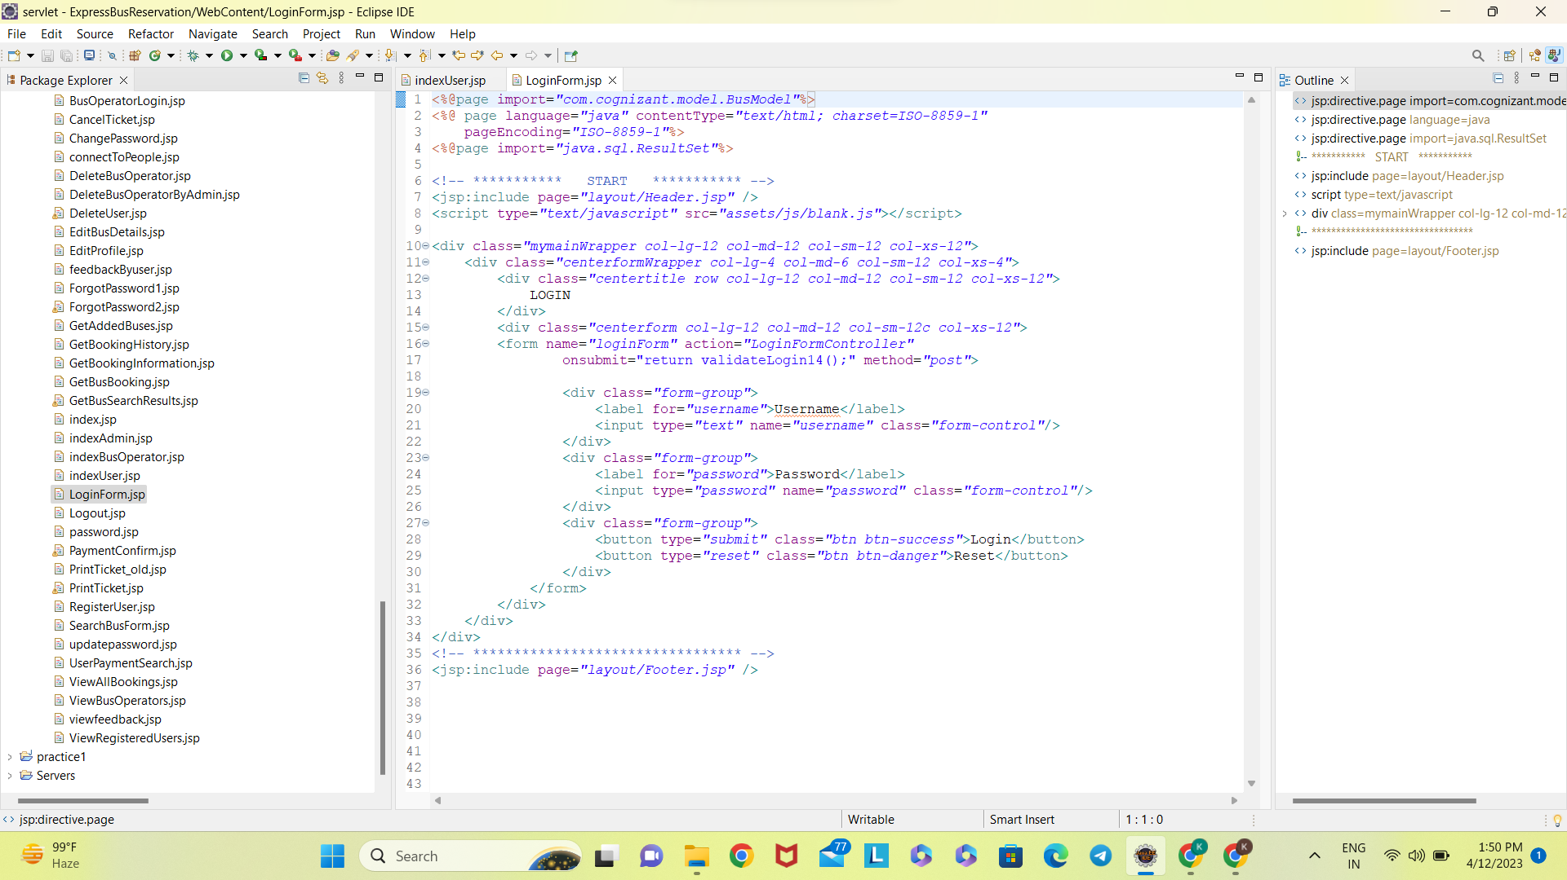

**loginBusOperator.jsp**

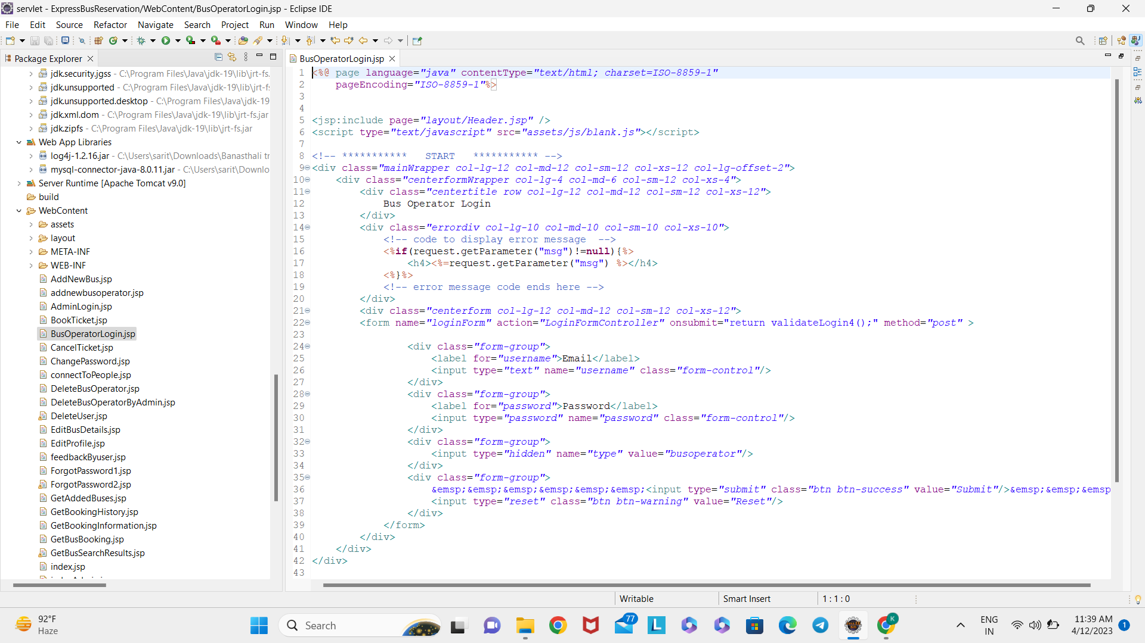

**LoginAdmin.jsp**

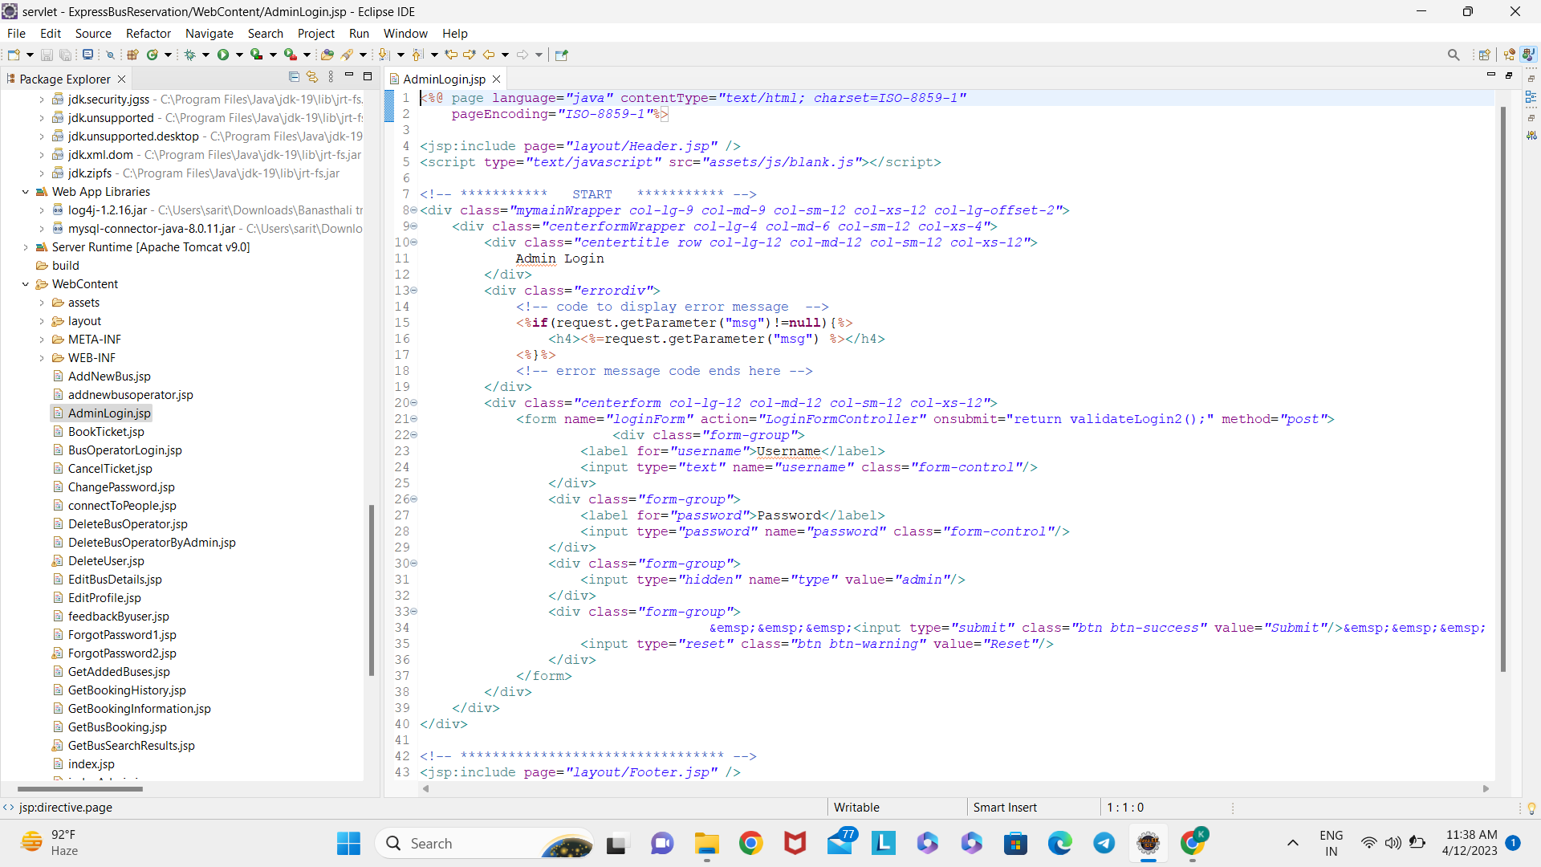

**SearchBus.jsp**

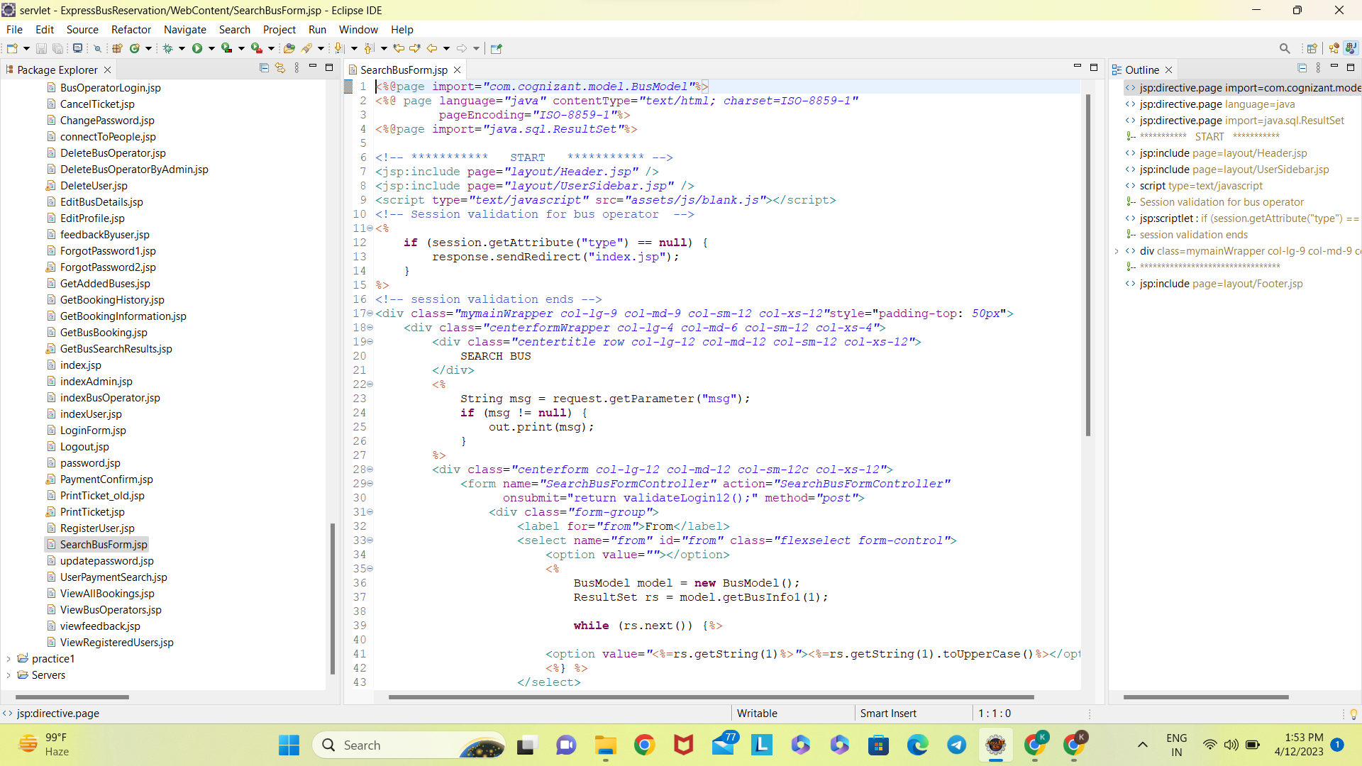

**Screenshot of pages**

**Homepage**

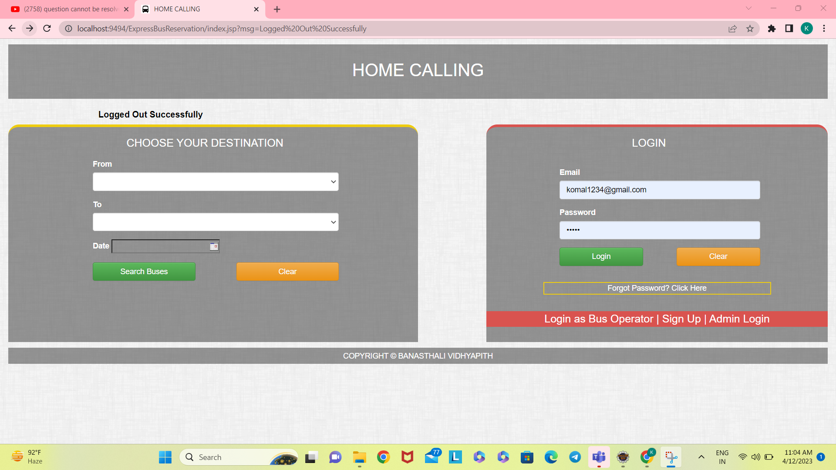

**Registration**

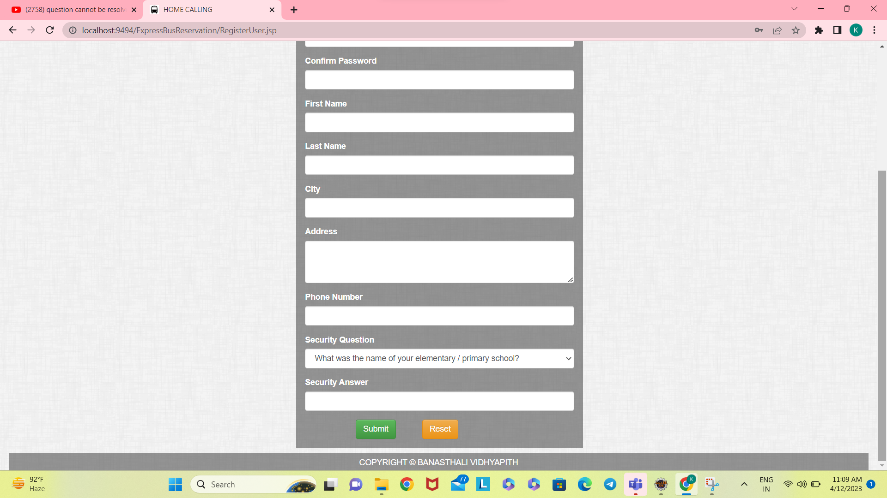

**Loginadmin**

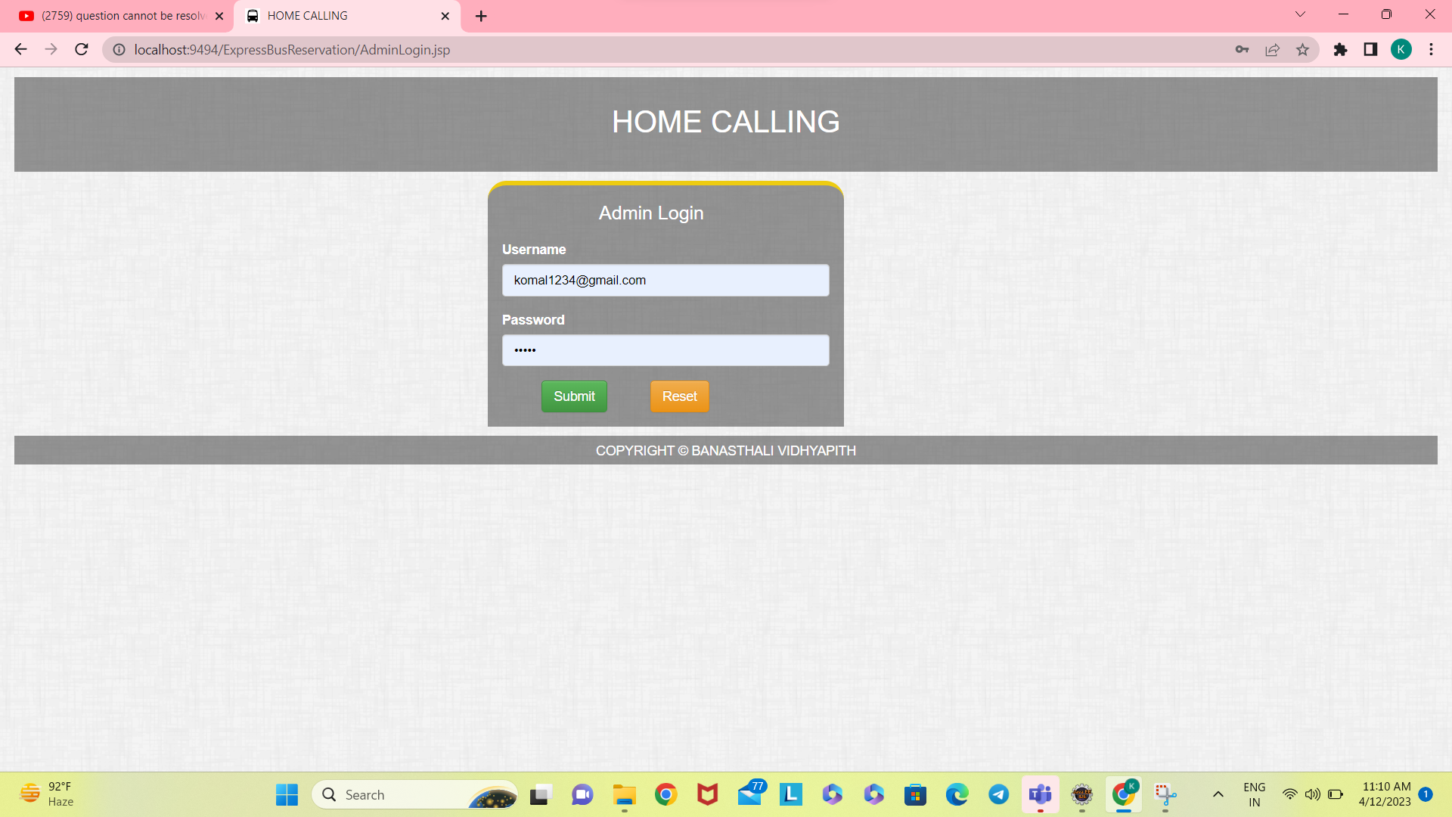

**loginBusOperator**

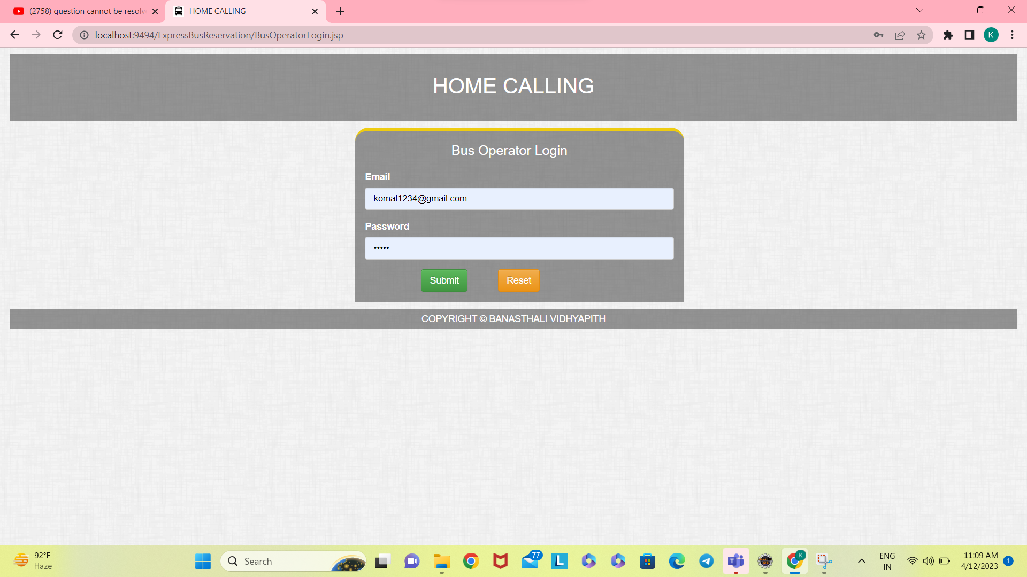

**loginUser**



**SearchBus**

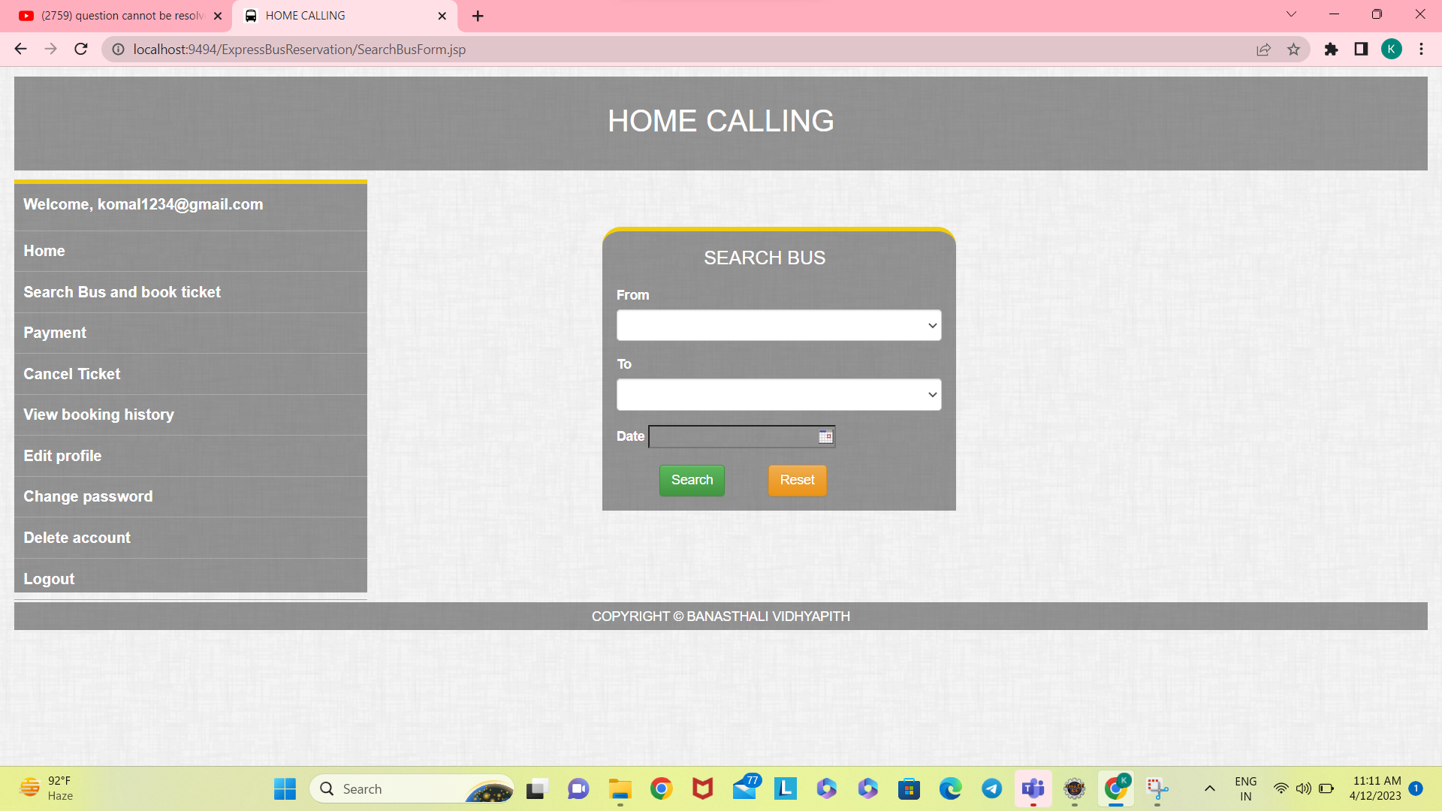

**Payment**

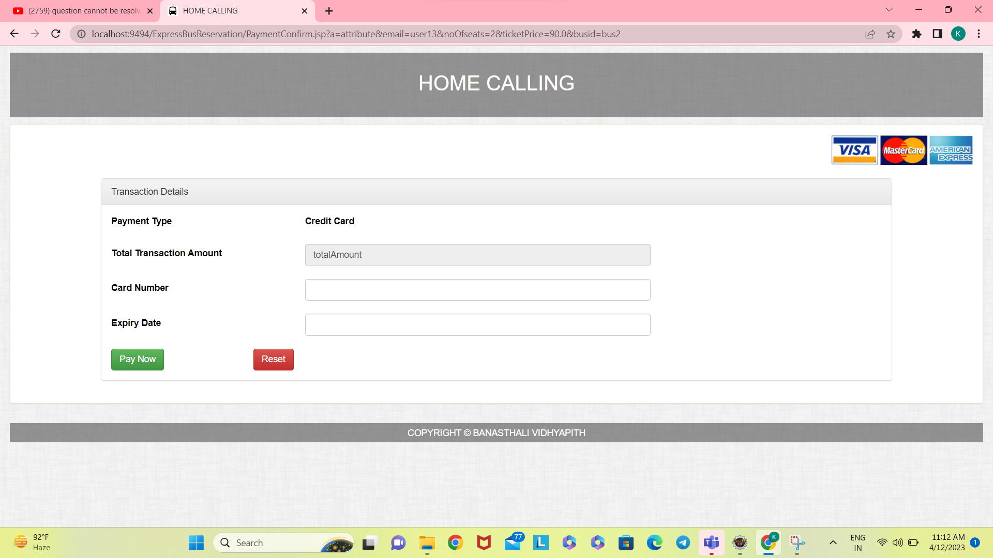

**Homepage of User**

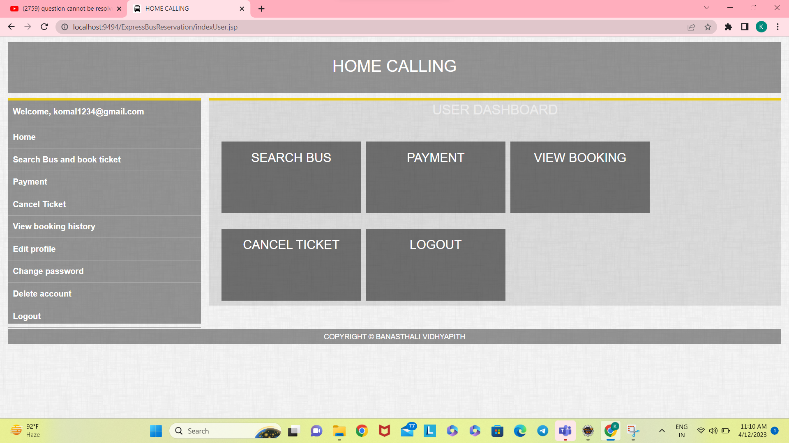

**Homepage of Bus operator**

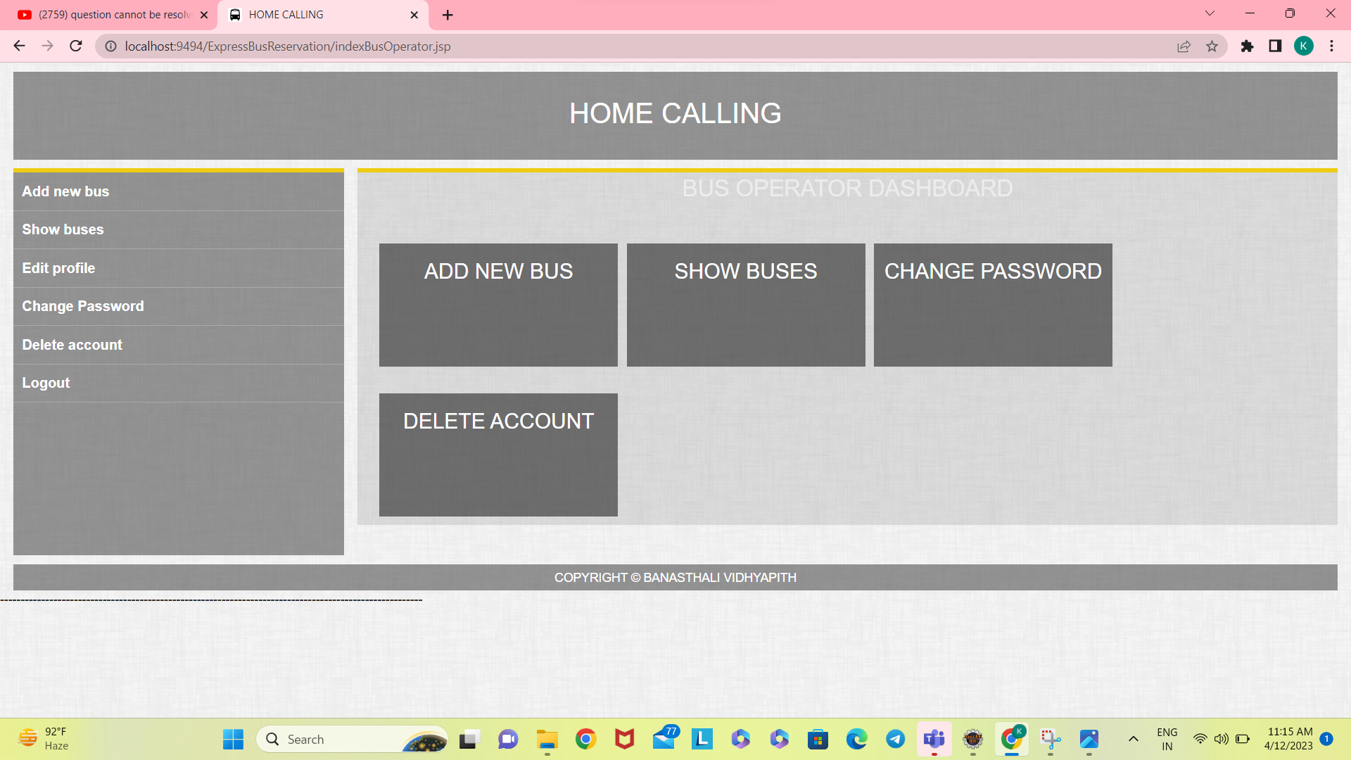

**Homepage of Admin**

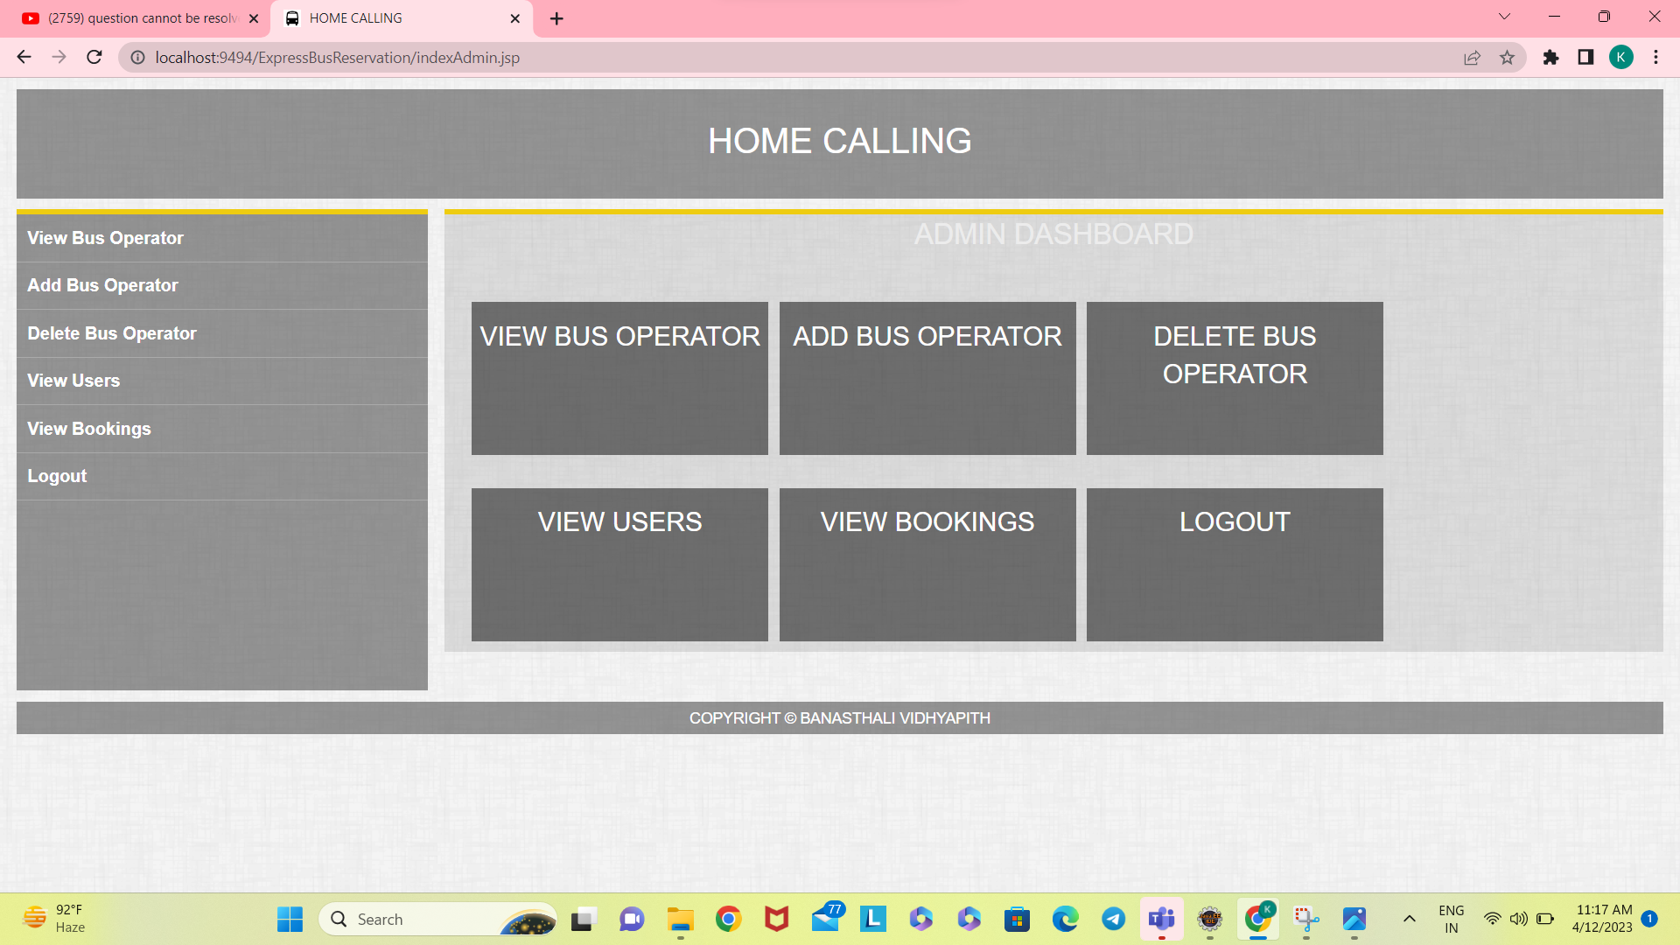

**TESTING**

initial Software testing can be stated as the process of validating ad verifying that a software program/ application/ product:

1. Meets the requirements that guided its design and development;

2. Works as expected; and

 3. Can be implemented with the same characteristics.

Testing is the process of making sure that the program performs the intended tasks.

**1. Unit Testing:**. Each component or part of the system is tested individually.

**2. Module Testing:** A collection of dependent components such as an object class, procedures, and functions are tested in this testing.

**3. Integration Testing:** In this, many units tested modules are combined into sub-systems, which are then tested.

**4. System Testing:** Entire system software is tested. It is a testing of the system against its objectives.

THANK YOU